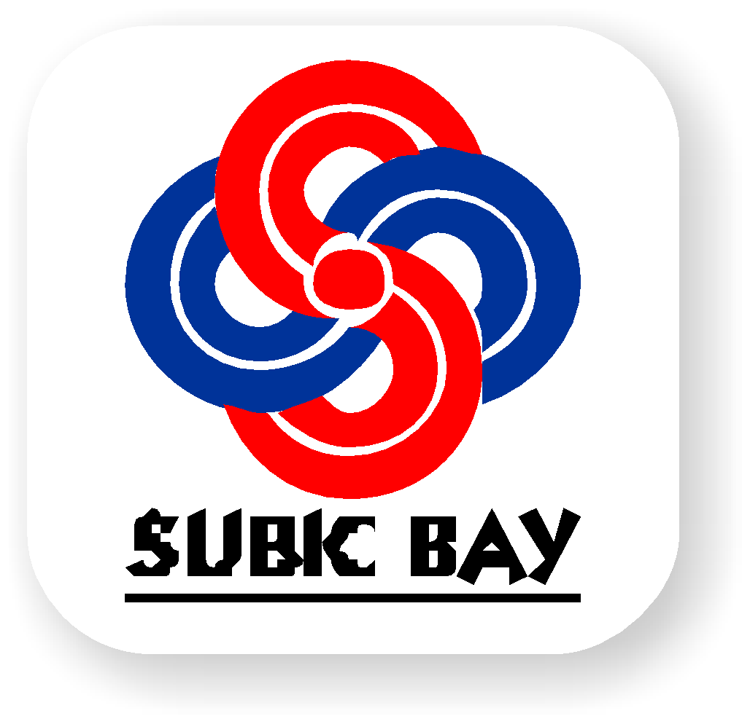 | SUBIC BAY METROPOPLITAN AUTHORITY  Human Resource Department

DEPARTMENT/OFFICE
NEW EMPLOYEE INDUCTION FEEDBACK FORM

Instructions:

- This form shall be accomplished by the New Employee (inductee) within one (1) week after his/her first thirty (30) calendar days in the Department/Office to evaluate the Induction Program of the Department/Office and shall be submitted to the Human Resource Department (HRD).

Name of Employee: ______________________________ Date Hired: __________________

Position Title: ___________________________________ Salary Grade: ________________

Department: ___________________________________ Division: ____________________

- Have you completed the Department/Office Induction Program?

YES NO

Any additional Comments:

______________________________________________________________________________________________________________________________________________________

- Were you personally introduce to your new colleagues, peers, manager, and other appropriate people during your first week in your work area?

YES NO

Any additional Comments:

______________________________________________________________________________________________________________________________________________________

- Has your Induction helped you understand your job, duties, responsibilities, and work standards?

YES NO

Any additional Comments:

______________________________________________________________________________________________________________________________________________________

- Have appropriate policies and procedures, important to your job (Quality, Environmental, Health and Safety Management, and work processes), been shown and explained to you?

YES NO

Any additional Comments:

______________________________________________________________________________________________________________________________________________________

- Has the SBMA Employee Handbook been of use to you?

YES NO

Any additional Comments:

______________________________________________________________________________________________________________________________________________________

- If there was/were aspect/s of your Induction that could be improved, what would it be and how it might be improved?

Aspect/s: ___________________________________________________________________

______________________________________________________________

Suggestions for improvement:

______________________________________________________________________________________________________________________________________________________

__________________________________ _______________________
Signature of the Employee Date

