Annex C

GUIDELINES ON EXPENSES

RATIONALE

These guidelines are consolidated primarily to allow SBMA employees, Members of the Board of Directors and stakeholders of SBMA to familiarize with the various expense classifications as well as the basic requirements and limitations of each expense for proper recording and easy processing of payment in case of availment.

OBJECTIVES

- To set up guidelines that will allow familiarization of various expense accounts by employees, Members of the Board of Directors and stakeholders of SBMA.
- To summarize all the requirements and limitations of each expense for easy processing of payment and proper recording purposes.

There are Four Major Classifications of Expenses

- Personnel Services (PS)

Refers to salaries, wages, other compensation (e.g., allowances of permanent, temporary, contractual and casual employees of the SBMA) and personnel benefits costs shall include salary increases, step increment, incentive and service fees, commutation of vacation and sick leaves, retirement and life insurance premiums, compensation insurance premiums, health insurance premiums, HDMF contributions, hospitalization and medical benefits, scholarship and educational benefits, all kinds of allowances, whether commutable or reimbursable, in cash or in kind, and other personnel benefits and privileges authorized by law, including the payment of retirement gratuities, separation pay and terminal leave benefits.

- Maintenance and Other Operating Expenses (MOOE)

All expenses of the corporation resulting from the conduct of operation other than Personal Services (PS).

- Financial expenses (FE)

Refers to Debt Service payment of the organization such as interest expenses, commitment fees charges.

- Capital Expenditures (CAPEX)

Refers to the infrastructure and non-infrastructure projects of the corporation such as construction of roads, ports, hospitals, irrigation facilities and other similar physical structures and facilities funded from corporate funds, borrowing or subsidy/equity from the national government. It also includes transportation equipment (motor vehicles, watercrafts and other related equipment), office equipment, furniture and fixtures, hand tools, medical equipment, security equipment, communication equipment, machineries, information technology equipment and other related equipment needed in the performance of line functions intended for administrative and support activities.

DETAILED DESCRIPTION

PERSONNEL SERVICES (PS)

This classification shall include all manpower and personnel benefit costs which may include but not limited to salary, salary increases, step increment, incentive and service fees, commutation of vacation and sick leaves, retirement and life insurance premiums, compensation insurance premiums, health insurance premiums, Home Development Mutual Fund (HDMF) contributions, hospitalization and medical benefits, scholarship and educational benefits, all kinds of allowances, whether commutable or reimbursable, in cash or in kind, and other personnel benefits and privileges authorized by law, including the payment of retirement gratuities, separation pay and terminal leave benefits of employees under the following plantilla employment status as approved by the Department of Budget and Management (DBM):

- Permanent - issued to a person who meets all the minimum qualification requirements of the positions to which he is being appointed, including the appropriate eligibility prescribed, in accordance with the provisions of law, rules, standards promulgated in pursuance thereof.

- Casual - issued only for essential and necessary services where there are not enough regular staff to meet the demands of the service.

- Government Contractual - issued to a person who shall undertake a specific work or job for a limited period not to exceed one year. The appointing authority shall indicate the inclusive period covered by the appointment for purposes of crediting services.

- Co-terminus - issued to a person whose entrance and continuity in the service is based on the trust and confidence of the appointing authority or of the head of the organizational unit where assigned; or co-existent with the incumbent; or limited by the duration of the project; or co-existent with the period for which an agency or office was created.

Any addition or deletion in the foregoing employment classification will have to be approved by the DBM.

Maintenance and Other Operating Expenses (MOOE)

      - Travel Allowance

- Local Travel Allowance Budget Form -302
Officials and employees of the government may be allowed for local travel allowance or reimbursement of travelling and related expenses incurred in the course of official travel.

Executive Order (EO) 77 (s.2019) amending Executive Order 298 (S.2004), EO 248 and 248-A (S 1995) provides the following standard rates for local travel allowance with overnight stay.

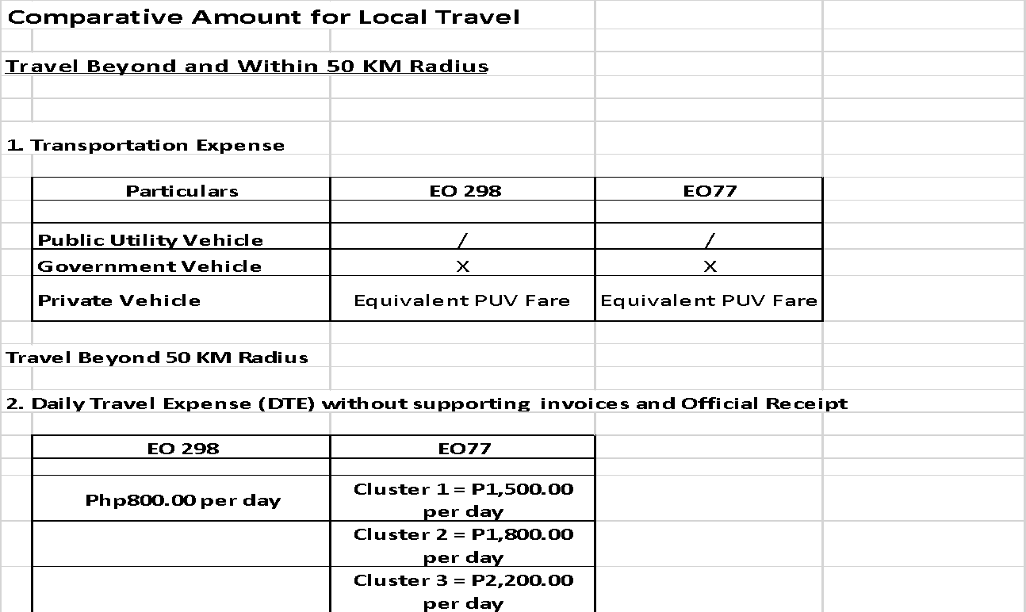

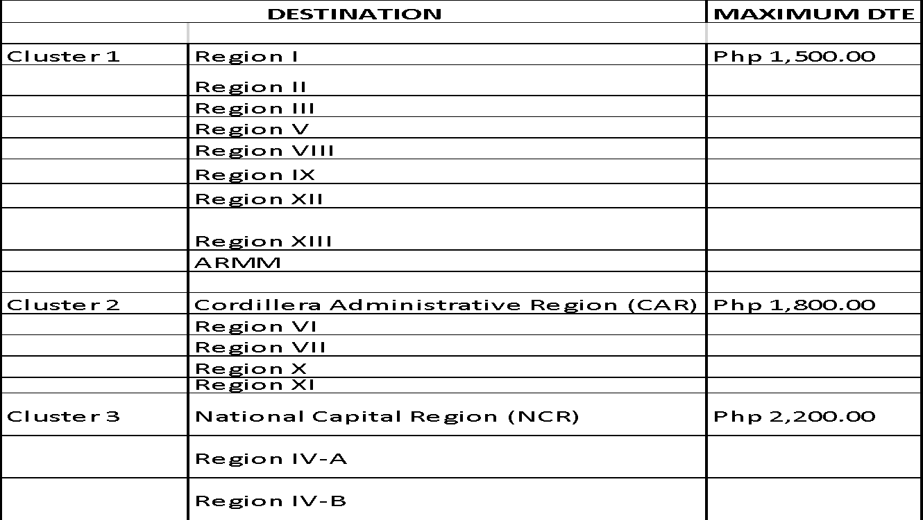
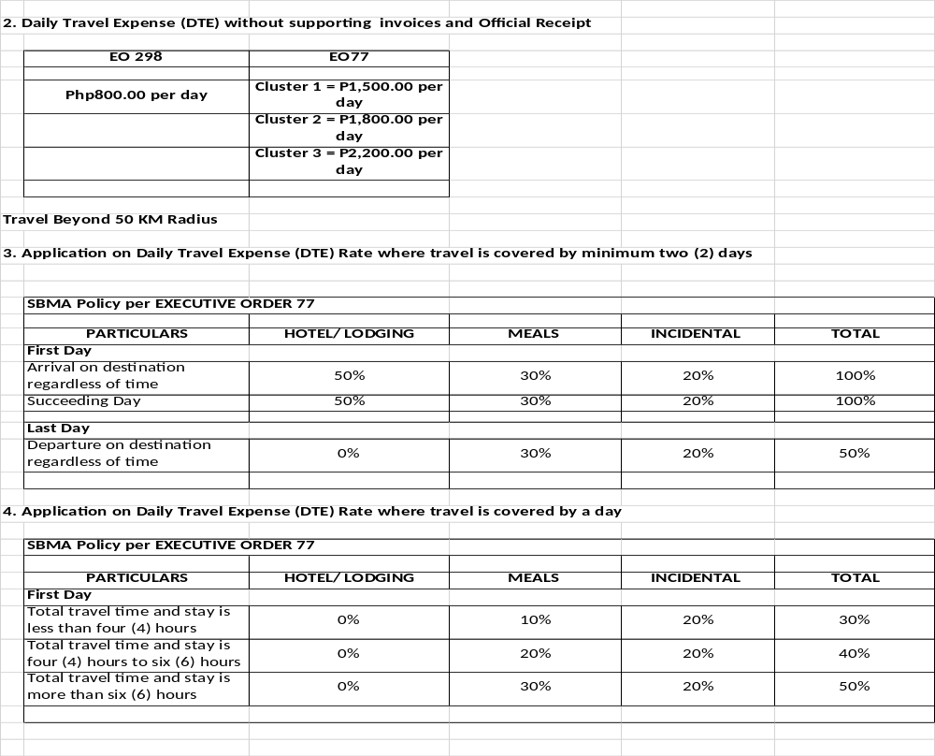
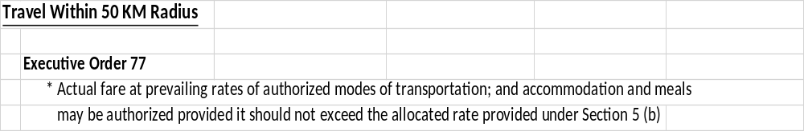

Transportation expenses such as toll fees, parking fees and public transportation fees shall be allowed in going to and from the place of official travel destination during meetings/training, on reimbursable basis, subject to presentation of Official Receipts.

Payment of claims for reimbursement of actual accommodation expenses (excluding expenses for valets, room attendants, laundry, pressing, haircut, and similar services furnished by the hotels) in excess of the accommodation component of the Daily Travel Expenses may be allowed, but in no case shall the difference exceed one hundred percent (100%) of such component of the prescribed DTE rate and only upon submission of the following: (1) certification by the Chairman & Administrator as absolutely necessary in the performance of an assignment, and supported by at least three (3) canvasses prior to departure, official receipt and allotment availability.

Documentary Requirements in case of Local Travel

- Duly Approved Authorization for Travel
- Itinerary of Travel
- Certificate of Appearance
- Certificate of Travel Completed
- Trip Ticket, in case of reimbursement of toll fees
To request for budget inclusion, Budget Form 302 shall be filled up and submitted to Human Resource Management Department (HRMD) on or before the required due date of submission of the Project Procurement Management Plan (PPMP) and may include the following:

- Training related – these are travel expenses related to external training/conferences/seminars for a maximum of five (5) days per training/conference/seminar per employee.

- Operations related – these are travel expenses related to attendance of various official meetings and site visits.

- Teambuilding/ Cascading activity - these are travel expenses related to departmental teambuilding/cascading activity. Please refer to the Accounting Department memo dated March 10, 2017 regarding Financial Guidelines on said activity and Human Resource Management Department memo dated February 14, 2018 on Revised Guidelines.

- B. Foreign Travel Allowance

Normally, no allocation is provided per department. The FPBD shall however provide for a lump-sum allotment under the Special Operation for Additional Revenues (SOAR) Project to provide for travel expenses that are focused on generating additional revenues. The charging of expenses to SOAR shall be subject to the approval of the Chairman and Administration upon the recommendation of the Strategic Business Unit (SBU) Heads.

Computation of Foreign travel allowance is based on the Daily Subsistence Allowance (DSA) as provided under the United Nations Development Program Index which can be secured from the Department of Foreign Affairs (DFA). The DSA shall be based on the daily rates established by the International Civil Service Commission (ICSC) of the United Nations which may be accessed at www.undp.org.ph or at www.dfa.gov.ph of the Department of Foreign Affairs (DFA). The apportionment as to hotel expenses, meals and incidental expenses depends on the country of destination.

Memorandum Circular No. 35 (Clarifying and Reinforcing Existing Rules and Regulations on Foreign Travel Authorities, Travel Entitlements, and Travel Tax Exemptions, Which Require the Approval of the Office of the President) dated November 22, 2017, which provides, among others, that no official travel abroad shall be allowed unless it satisfies all of the following minimum criteria: (a) the purpose of the trip is strictly within the mandate of the requesting government official or personnel; (b) the projected expenses for the trip are not excessive; and (c) the trip is expected to bring substantial benefit to the country.

There are two steps in processing payment for foreign travel allowance:

Cash advance and liquidation of cash advance. Payment initially through cash advance. The following are the documentary requirements in case of cash advance for foreign travel:

- Invitation for the trip
- Duly Approved Authorization for Foreign Travel
- Itinerary of Travel
- DSA Rate which shall be computed by the Accounting Department
- Office Order
- Duly Accomplished Cash Advance Form
- Trip Ticket in case SBMA will shoulder the plane ticket

Liquidation of cash advance. The following are the documentary requirements in case of liquidation of cash advance used for foreign travel:

- Certificate of Appearance
- Certificate of Travel Completed
- Boarding Pass
- Narrative Report on Trip Undertaken
- Revised Itinerary of Travel, if needed
- Duly Signed and Accomplished Budget Utilization Request

Reimbursement of Foreign Travel Expenses

      - Memorandum requesting for reimbursement foreign travel expenses
      - Invitation for the trip
      - Duly Approved Authorization for Foreign Travel
      - Itinerary of Travel
      - DSA Rate which shall be computed by the Accounting Department
      - Office Order
      - Trip Ticket in case SBMA will shoulder the plane ticket
      - Certificate of Appearance
      - Certificate of Travel Completed
      - Boarding Pass
      - Narrative Report on Trip Undertaken
      - Revised Itinerary of Travel, if needed

To request for budget inclusion, Budget Form 302/302A must be accomplished and submitted to the Financial Planning and Budget Department on or before the required due date of submission of the Project Procurement Management Plan (PPMP).

Grant of Ancillary Benefits for Contract of Service and Job Order Workers (Board Resolution No. 26-01-1655 dated Jan. 27, 2026 per COA-DBM JC No.1, s. 2025 dated 12/15/2025 and COA-DBM JC No. 1, s.2022 dated 09/13/2022 and CSC MC No.1, s. 2026 dated 01/01/2026), per HRMD memorandum dated Jan. 29,2026, such ancillary benefits are the following:

- Compensatory Time Off (CTO)
- Flexible Working Arrangement (FWA)
- Reimbursement of Authorized Official Travel Expenses
- Wellness Leave

- Communication Expenses Budget Form -303

The following are the regular communication expenses of SBMA:

  - Landline/Leased lines – the Telecoms Department normally evaluates the request for additional line and its evaluation is limited only to the following technical matters:

- Digital Phone – no extension is allowed
- Analog Phone – maximum of two (2) extensions are allowed
- Availability of line circuits in the area

  - Mobile phone services – the following are the officials and employees who are qualified to utilize mobile phone for official use and the corresponding allowed spending limit per month: (effective August 2016)

Position | Spending limit
Chairman | P 20,000.00
Administrator | P 20,000.00
Senior Deputy Administrator | P 3,500.00
Deputy Administrator | P 3,500.00
Department Manager | P 2,500.00
Chief of Staff (for the Chairman and Administrator) | P 1,800.00
Division Chief | P 1,200.00
Executive Assistant (for the Chairman and Administrator) | P 800.00
Consultant (as provided in the contract) | P 800.00
Others (including Account Officers, Security escort for the Chairman/LED Desk Officer for E911, etc.) | P 500.00

Guidelines on Mobile Phone/Subscription Plan

The mobile phone/ subscription plan shall be dependent on the availability of funds allocated for the communication expenses of the requesting department. Entitlement to mobile phones shall terminate the use of existing PIN NDD-Access to limit Communication Expenses.

Requests for exemption, to increase the existing subscription plan or the proposed spending limit shall be pre-approved by the Board of Directors with prior approval of the SBU Head and the Administrator, thru the DA for Finance.

Request to avail new mobile phone subscription shall be approved by the SBU Head subject to necessity and availability of funds of said department as certified by FPBD.

Mobile phone assignees are entitled to consume up to the extent of allocated spending limit for the following basic services:

        - Voice Call Services
        - Mobile to Mobile
        - Mobile to Landline
        - NDD access for Domestic Long Distance
        - Short Message Services
        - Text to all Service Provider Networks

In the event that the assignee is separated from employment, the concerned immediate superior shall take on the responsibility of retrieving the unit and to internally redeploy the account to the person who shall assume the vacated position. This is to continue the subscription for the remainder of the contract and to avoid penalty as levied by the Service Provider. Also, the PIN account of said person shall be deactivated in lieu of the mobile phone.

The following shall be considered personal and shall be billed to and paid by the assignee:

        - Usage in excess of approved spending limit
        - Costs incurred for Enhanced Services enjoyed exclusive of the consumable basic services.
        - Costs incurred for IDD access for International Long Distance and International Roaming except when the assignee and the party/official being called is on Official foreign travel.
        - Usage during prolonged leave of absence (above 10 working days). The official who authorized the leave shall notify the Telecoms Department for the computation of the charges.

With regards to issuance of Billing Assessment for personal charges, the following timeline should be observed:

DATE | PARTICULARS | RESPONSIBLE DEPARTMENT
Last working day of the billing month | Issuance of Billing Assessment (BA) | Telecoms
7th day (of succeeding month) | Payment due date of BA | Assignee
10th day (of succeeding month) | Provide Treasury list of unpaid BA | Telecom
15th day (of the month) | Provide Land-bank a Letter of Authority to deduct charges from Assignee’s salary | Treasury
16th day (of billing month) | Apply credit memo of salary deductions to proper billing assessment | Treasury

Reimbursement of Certified Official Usage may be allowed when the assignee certifies that the excess is for official business. Claims for reimbursement shall be accompanied with a list that accounts the name, company, contact number and official designation of the party called. The claim for reimbursement shall be endorsed by concerned Department Head for approval of their respective SBU Head, chargeable against savings from the department’s operation. Approving authority is as follows:

POSITIONS | ENDORSED BY | APPROVED BY
Department Manager and Below | Deputy Administrator | SBU Head
Deputy Administrator | Senior Deputy Administrator | Administrator
Senior Deputy Administrator |  | Chairman and Administrator

As for the handsets, the assignee is expected to take proper care and maintenance of the unit. Repair costs of damaged handsets and sim card for defects from abuse or misuse not covered by warranty shall be shouldered by the assignee as determined by Telecoms Department.

As for lost/stolen handsets, the following procedures shall be observed:

- The assignee shall first notify the Telecoms Department for temporary deactivation of line.
- The assignee to prepare Incident Report to be endorsed to LED for investigation.
- Assignee to request relief of accountability to the Administrator and CEO. The Administrator and CEO shall endorse the request for relief of accountability to COA.
- As for the handsets under expired subscription of Service Provider, the assignee shall endorse the unit to Telecoms Department for inspection. The latter shall turn over the non-serviceable units to the Procurement and Property Management Department for proper disposal. Mobile phones are advantageous for mobility of transactions however the assignee is encouraged to maximize the use of landline and Internet services.

  - Postal/Courier Services – This account is for all expenses for mailing letters and documents within or outside the Subic Bay Freeport Zone. Budget allocation is usually based on trend or utilization of the budget.

  - Internet/DSL – This account includes all expenses related to our connectivity to the internet. Budget allocation is usually based on recommendation of the Information Technology Department.

To request for budget inclusion, Budget Form 303 must be accomplished and submitted to the Financial Planning and Budget Department on or before the required due date of submission of the Project Procurement Management Plan (PPMP).

- Repairs and Maintenance – Building and Facilities Budget Form -304

This account includes the cost for minor repairs only of SBMA buildings and facilities such as public buildings, housing units, roads, bridges, utility systems, seaports, wharves, parks and other public facilities.

Work programs should have the appropriate scoping/cost estimates from the Engineering or Construction and Maintenance Department.

To request for budget inclusion, fill up Budget Form – 304 for project details and submit to the Office of the Deputy Administrator for PWTSG (ODA-PWTSG) for coordination with Engineering Department and Construction and Maintenance Department (CMD) for evaluation, consolidation and scheduling by year.

- Repairs and Maintenance – Government Vehicles Budget Form -305

This account includes the cost for minor repairs only of SBMA vehicles (including watercrafts) such as services, spare parts and materials. Observe restrictions based on COA Circular 2012-003, section 4.0 (Annex C) unnecessary expenditures and section 5.0 (Annex D) as excessive expenditures.
Repair works shall be requested to the Construction and Maintenance Department for validation and endorsement for budgeting purposes. Fill up Budget Form – 305 for details and submit it to the Construction and Maintenance Department for evaluation, consolidation and scheduling by year.

- Supplies and materials Budget Form - 307
This account includes the cost of all expendable commodities acquired or ordered for immediate use in connection with SBMA operations. Included herein are: accountable forms/office supplies/ non-accountable forms/animal or zoological supplies/food supplies/welfare goods/drug and medicines/medical, dental and laboratory supplies/printing of calling card, housekeeping and cleaning supplies/ other supplies. This account also includes batteries and tires.

It also includes the cost of all semi-expendable items/equipment which amount is less than P50,000.00 (formerly P15,000.00). These tangible items shall be recognized as expenses upon issue to the end-user. Please refer to COA Circular 2022-004 dated 05/31/2022 amending Department of Budget and Management (DBM) Circular Letter 2016-7 (s. July 2016).

Fill up Budget Form – 307 for details and submit it to the Financial Planning and Budget Department for consolidation prior to sending to PPMD for evaluation and review.

- Rents Budget Form - 308
This account includes the cost for booth/space rental, copying machine charges and rental of equipment.

The Management Information Systems Office (MISO) does the allocation of rental for copying machines. In case there is a need for a budget for booth/space rental as well as rental of equipment Form - 308 must be accomplished and sent to FPBD.

- Awards and Indemnities Budget Form -311
This account includes the cost for Employee of the Quarter, Employee of the Year, Loyalty Award, Model Contract of Service Personnel (Semestral award), cash gift award for retiree and other related expenses thereto. Normally, the HRMD does the allocation for this account.

Fill up Budget Form – 311 for details and submit it to the Financial Planning and Budget Department.

- Power/Water Budget Form -314
This account includes the cost of water and power of all government used facilities. The Utilities Department provides for the estimated amount based on the previous year’s consumption. In case there is a need for additional allocation, Budget Form - 314 must be accomplished and sent to the Utilities Department for consolidation.

- Training – Local Budget Form -317
Human Resources Development and Training Programs should be responsive to the training needs of personnel and manpower requirements of the agency. It should also include human resource development and training programs that will promote high morale, efficiency, integrity, responsiveness, progressiveness, courtesy, nationalism and patriotism. Training programs should be consistent with the rules and regulations issued by the CSC for the purpose.

General Provisions were based on National Budget Circular (NBC) No. 596 (S.2025), National Budget Circular (NBC) No. 563 (S.2016), National Budget Circular (NBC) No. 442 (S. 1995) and NBC No. 486 (S. 2003).

The budget estimates shall cover the following:

    - On-site Training. Departmental submission for the purpose will be distributed to the following: For Registration Fee and Honoraria, these will be handled by HRMD, while the amount for Food and Accommodation, both for participants and speaker/s will be handled by Office Services Department (OSD).

    - Departmental Training Re-echo. Amount to cover snacks of participants in case of re-echo must be included in your departmental submission.

    - NON-Continuing Professional Development (CPD) training/ seminars/conferences shall be allowed upon approval of the Office of the Senior Deputy Administrator for Support Services provided that necessary budget realignment/ amendment/ inclusion are made.

For Continuing Professional Development (CPD) in compliance with Professional Regulations Commission (PRC) requirement for RA 1080 Eligible, there is a maximum of forty (40) hours CPD Training per person @ P2,800/day (formerly P2k each participant). Fill up Budget Form – 317 with the list of personnel that needs CPD credits and the schedule for attendance/availability of the training, then submit to the Human Resource Management Department for evaluation, consolidation and scheduling by year.

Membership and similar fees paid for personal or individual membership in a private organization shall be for the account of the member concerned and shall not be charged to agency funds. On the other hand, institutional membership fees, i.e., agency membership, may be charged against the respective agency funds. (NBC 596 sec. 3.4, s. 2025).

    - Normally, no fund is allotted for foreign training. In highly meritorious cases, the expense shall be chargeable against savings as certified by the Finance Group subject to approval of the Chairman and Administrator upon the recommendation of the SBU Heads.
    - All plantilla personnel availing both NON-CPD and CPD training shall not exceed the maximum allowable 40hrs per employee per year (refer to FPBD memorandum dated October 24, 2017).

- Extra-ordinary and Miscellaneous Expenses Budget Form -318

Extraordinary and miscellaneous expenses are for reimbursement only and the sponsoring official shall be present in case of availment. This shall include but not be limited to the following expenses:

            - Meetings, seminars and conferences;
            - Official entertainment;
            - Public relations;
            - Educational, athletic and cultural activities;
            - Contributions to civic or charitable institutions;
            - Membership in government associations;
            - Membership in national professional organizations duly accredited by the Professional Regulations Commission;
            - Membership in the Integrated Bar of the Philippines;
            - Subscription to professional technical journals and informative magazines, library books and materials;
            - Office equipment and supplies;
            - Other similar expenses not supported by the regular budget allocation.

FPBD shall provide allocation based on the General Provisions of the General Appropriations Act.

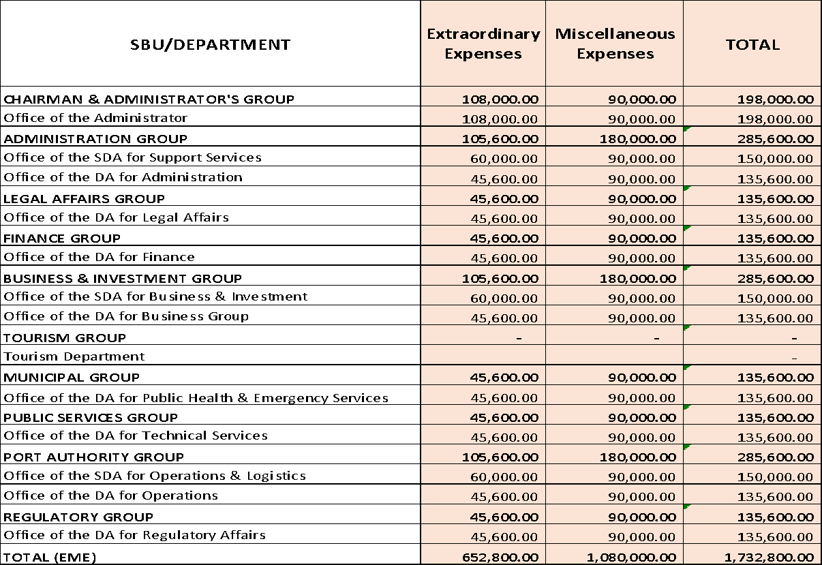

Note: Department/Offices reflected on the above table are based on the SBMA Organizational Structure as approved by the DBM and Office of the President.

- Taxes, Duties and Fees Budget Form -321

Payment of motor vehicles registration, firearms licenses, real property tax and other taxes. For motor vehicles registration, kindly coordinate with MTD – Transportation Division for annual expenses per vehicle assigned to your department. The budget for real property tax will be handled by the LADD while the budget requirement for firearms licenses will be submitted by the LED.

- Fuel, Oil and Lubricants Budget Form -323

Fuel allocation of the Board will be based on Executive Order No. 24 (s.2011) while fuel allocation for the management shall be based on the Board approved guidelines, Resolution No. 13-05-4766 (S.2013) as follows:

Department/Office | Fuel Allocation (Monthly)
Chairman and Administrator’s Office | 2,000 liters
Chief Operating Officer's Office | 1,000 liters
Planning and Development’s Office | 400 liters
Public Relations Department | 500 liters
Media Production Department | 300 liters
Intelligence Office | 500 liters
Internal Audit Service | 200 liters
Management Information Systems Office | 200 liters
Board Secretariat | 200 liters
Office of the SDA for Support Services | 200 liters
Office of the DA for Administration | 200 liters
Human Resource Management Department | 200 liters
Department/Office | Fuel Allocation (Monthly)
Procurement and Property Management Department | 1,000 liters
Office Services Department | 600 liters
Office of the DA for Legal Affairs | 200 liters
Legal Department | 500 liters
Labor Department | 500 liters
Office of the DA for Finance | 200 liters
Accounting Department | 300 liters
Financial Planning and Budget Department | 200 liters
Treasury Department | 1,000 liters
Office of the SDA for Business and Investment | 200 liters
Land and Asset Management Department | 600 liters
BID for Logistics | 300 liters
BID- GBID | 300 liters
BID-Leisure | 300 liters
BID-Manufacturing and Maritime | 300 liters
BID-ICT | 300 liters
Office of the DA for Tourism/ODA Business Group | 200 liters
Tourism Department | 1,500 liters
Office of the SDA for PWTSG | 200 liters
Fire Department | 2,500 liters
Law Enforcement Department | 25,000 liters
Public Health Department | 1,000 liters
Office of the DA for PWTSG | 200 liters
Engineering Department | 600 liters
Construction and Maintenance Department | 25,000 liters
Office of the SDA for Port Operations | 200 liters
Airport Department | 1,500 liters
Airport Department (Genset) | 6,000 liters
Seaport Department | 1,500 liters
Seaport Department (Vessel) | 4,000 liters
Trade Facilitation and Compliance Department | 200 liters
Office of the SDA for Regulatory | 200 liters
Safety Department | 200 liters
Ecology Department | 1,000 liters
Telecommunication Department | 800 liters
Visa and Accreditation Processing Office | 200 liters
Regulatory Monitoring Unit | 1,000 liters

Others not availing Transportation Allowance allocations are the following:

Department/Office | Fuel Allocation (Monthly)
Senior Deputy Administrators | 400 liters
Deputy Administrators | 300 liters
Department Managers | 200 liters
Division Chiefs | 120 liters
Pastolan Tribal Group | 250 liters

For liquidation of cash advances for fuel, the FPBD also requires a duly signed and accomplished Budget Utilization Request form for proper monitoring and recording of transactions.

The PPMD handles the allocation and issuance of the fuel/ticket based on the policy. Departments/offices are however required to fill up the form and submit to PPMD since there are departments/offices that have fuel allocation but do not have transportation equipment at the moment. Fill up the Budget Form – 323.

The SBMA currently uses the Fuel Fleet Card System, for the guidelines on the use of the said system, please refer to the PPMD memorandum dated January 6, 2026 - “REQUEST FOR INCLUSION IN THE AGENDA FOR MANAGEMENT COMMITTEE MEETING (Guidelines on Fleet Card Issuance and Withdrawal)”.

- Fidelity Bonds & Insurance Premiums Budget Form -324

This account includes payment of:

- Fidelity Bond shall include expenses for premium on fidelity bond of accountable officers.
- Insurance shall include premiums for the insurable risks of government property such as Land/Water/Air Transportation, Buildings, Airport Equipment, Electronic Equipment, DOLI and Marine Hull.

- Repairs and Maintenance of Other Equipment Budget Form -329A

This account includes the cost for minor repairs of equipment like air conditioning unit, camera, etc., such as services, spare parts and materials.

Request for repair works shall be coursed through to the appropriate Expense Account Manager (EAM) for validation and endorsement to FPBD for budgeting purposes. Fill up Budget Form-329A for details and submit it to the designated EAM for evaluation, consolidation and scheduling by year.

- Consultancy Budget Form -329B

Professional consultancy services include contracts with individual consultants, an expert in a field of special knowledge or training who is contracted to render particular outputs or services primarily advisory in nature requiring highly specialized or technical expertise which cannot be provided by the regular staff of the agency. Such hiring creates no employer-employee relationship between the individual consultant and the agency. This may cover office consultants and project consultants.

Consultancy services shall be requested to the Chairman’s Office. Fill up Budget Form -329B for details, indicating whether new or continuation of existing contract, and submit it to the Chairman’s Office for evaluation and approval.

- Advertising and Promotional Expenses Budget Form -329C
This account includes expenses for advertisement. It is important to note that these must be ordinary and reasonable expenses for advertising. Some examples would be newspaper advertisements, TV and Radio ads costs (including production costs), and costs for setting up a website. Expenses for promotion activities, like special events and costs for meals and entertainment for promotion activities.
Fill up Budget Form-329C for details and submit it to the Financial Planning and Budget Department together with the details and justification to include in the budget.

- All Other Services Budget Form -329D

This account includes expenses that are not covered by the foregoing expense accounts which may include but not limited to the following: grants, subsidies, contributions, legal services, printing expenses, pest control, maintenance services, manuals, memberships, subscriptions, meals for management and various committee meetings. Fill up Budget Form-329D for details and submit it to the Financial Planning and Budget Department together with the details and justification to include in the budget.

- Contract of Services/ Job Order Budget Form -329E

This account includes expenses for the salaries of the Contract of Services and Job Order personnel.

Fill up Budget Form-329E for details and submit it to HRMD together with the details and justification to include in the budget.

For the guidelines in the hiring of CS/JO personnel, please refer to CSC, COA and DBM Joint Circular No. 1 s. 2025 dated December 15, 2025 - REVISED RULES AND REGULATIONS ON THE ENGAGEMENT OF THE CONTRACT OF SERVICE AND JOB ORDER WORKERS IN THE GOVERNMENT

- Representation Expenses Budget Form -329F

This account includes expenses for the meetings/conferences and official functions not related to training being undertaken by government corporations with outside organization.

Fill up Budget Form-329F for details and submit it to the Financial Planning and Budget Department together with the details and justification to include in the budget.

Revised Chart of Account 2019 (COA Circular # 2020-002 dated 1/28/2020)

- Major Events and Conventions Expenses Budget Form -329G

This account includes expenses incurred related to the holding of major activities such as; GAD activity, Year-end Activity, Cultural and Athletic Activity (Anniversary with Mini Olympics and Senior Citizen Activity, Religious Events, Family Day) and/or events and conventions not related to training being undertaken by government corporations.

GAA provides an amount not exceeding PhP1,500 in a year to be used for the purchase of uniform or costume and other related expenses in the conduct of cultural and athletic activities per plantilla employee.

- Except for the expenses related to the meetings of the Board of Directors, Authorization for Chargeable Expenses (ACE) is no longer allowed.

- All food provision for the year shall be consolidated by the OSD and procurement of separate food provision is not allowed if the amount will not exceed P1,000,000.00.

Revised Chart of Account 2019 (COA Circular # 2020-002 dated 1/28/2020); Please refer to GAA every year guidelines. SBMA Board Resolution No. 25-11-1582 dated 12/12/2025 (Revised Guidelines for Food Provision)

Fill up Budget Form-329G for details and submit it to the Financial Planning and Budget Department together with the details and justification to include in the budget.

PETTY CASH FUND (PCF)

In SBMA, the PCF was initially established at the Treasury Department in the amount of P100,000 and the Head Cashier was designated as PCF Custodian for small purchases for goods and services worth up to P2,500 per transaction to facilitate immediate purchase of office supplies, and/or repairs of motor vehicle or equipment but not for regular inventory items for stocking. In the exigency of the service, other departments and offices were authorized in various amounts to maintain separate PCFs.

COA Circular No. 2012-001 dated June 14, 2012 provides among others the following General guidelines and documentary requirements common to all cash advances: Authority of the accountable officer issued by the Head of Agency should indicate the maximum accountability and purpose of cash advance. Transfer of cash advances from one accountable officer to another shall not be allowed. This policy is also stated under Sec. 174.d, Volume I of the Government Accounting and Auditing Manual (GAAM).

Guidelines in Granting and Utilizing of PCF

- Only permanent employees designated as “Special Disbursing Officer” by the SBMA Chairman and Administrator and covered with fidelity bond issued by the Bureau of Treasury shall be granted PCF.

- The PCF shall be used only for the specific legal purpose (see Sec. 2) for which it was granted.

- The cash advance for PCF shall be sufficient for the petty operating expenses of the department. Note: Financial Planning & Budget Department (FPBD) shall ensure that the quantity of item (supplies) for procurement is not for more than one (1) month.

- The PCF Custodian may request for replenishment of the said fund when the disbursement reaches at least 75% or as the need requires.

- Transfer of PCF from one (1) Custodian to another shall not be allowed.

- No PCF Custodian shall be allowed to handle two (2) PCF at the same time.

- The PCF shall not be used for payment of regular expenses such as rentals, subscriptions, light, water and the like.

- PCF shall be used exclusively by the concerned SBU, office or department only. Other SBU’s, offices or departments without PCF shall request petty cash from the PCF Custodian at the Treasury Department.

Threshold/ Limit in the Availment of Cash Advance from PCF:

      - For replacement of spare parts - Other Department’s PCF - P5,000 /Treasury Department’s PCF – P10,000

      - For Office Supplies - Other Department’s PCF/ Treasury Department’s PCF – P2,500

      - For Services/Repairs and Maintenance of Equipment - Other Department’s PCF - P5,000/ Treasury Department’s PCF – P10,000

      - Food Provision for Meetings- Other Department’s PCF/Treasury Department’s PCF– P5,000
      - Other Materials - Other Department’s PCF - P5,000 / Treasury Department’s PCF – P10,000

      - Payment for Toll Fees/ Parking Fees

Other Department/ Treasury – Metro Manila Area
Class 1 – For 4 wheels like Car - P500
Class 2 – For 6 wheeler or 7 ft. like Coaster – P1,000
Class 3 – For Heavy Equipment like 10-wheeler – P1,500

Other Department/ Treasury – Outside Metro Manila Area
Class 1 – For 4 wheels like Car – P800
Class 2 – For 6 wheeler or 7 ft. like Coaster – P1,500
Class 3 – For Heavy Equipment like 10-wheeler – P2,500

The Maintenance and Transportation Department shall provide the cash advance for the Toll Fees and Parking Fees of the drivers they provide on official travels. On the other hand, drivers of other departments may request cash advances from the Treasury Department for the same purpose.

Documentary Requirements for Submission to Accounting Department for Initial Set-up of PCF

- Memo request to set up PCF addressed to Office of the Deputy Administrator (ODA) for Finance for review/validation and endorsement for approval by the Administrator. The memo should cite the purpose/justification for setting the PCF, the desired amount and who would be the custodian

- Office Order designating the personnel as Special Disbursing Officer to handle the Petty Cash Fund and stating the purpose and amount of the Fund.

- Budget Utilization Request (BUR)

- Copy of Bureau of Treasury (BTr) Confirmation letter of fidelity bond of PCF Custodian or memo from Treasury Department to Accounting Department together with proof of payment certifying that the fidelity bond was processed and paid to the BTr.
Documentary Requirements for the Grant of Cash Advance from PCF

PCV Number shall be assigned by the PCF Custodian upon liquidation of petty cash advances or payment of the reimbursement with applicable supporting documents depending on the transaction type as follows:

1. Purchases for replacement of spare parts

- PCV with complete data and signature
- Stock Availability Inquiry (SAI)
- Technical Evaluation
- Work authorization and related documents
- Vehicle/ Equipment Maintenance Service Request Form
- Original copy of Canvass from at least three (3) suppliers
- Summary/ Abstract of Canvass/Purchase Request form/ Statement of Urgency (Signed by Manager and ODA or OSDA)
2. Purchases of Office Supplies and Other Materials

- PCV with complete data and signature
- Stock Availability Inquiry (SAI)
- Approved Purchase Request (PR) with certificate of Emergency Purchase
- Original copy of Canvass from at least three (3) suppliers
- Summary/ Abstract of Canvass/ Purchase Request form/ Statement of Urgency (Signed by Manager and ODA or OSDA)

3. Services/ Repairs & Maintenance of Equipment

- PCV with complete data and signature
- Stock Availability Inquiry (SAI)
- Approved PR with certificate of Emergency Purchase
- Technical Evaluation
- Vehicle/ Equipment Maintenance Service Request Form
- Original copy of Canvass from at least three (3) suppliers
- Summary/ Abstract of Canvass/ Purchase Request form/ Statement of Urgency (Signed by Manager and ODA or OSDA)

4. Purchases of Food Provision for Meetings

- PCV with complete data and signature
- Letter of Invitation/ Notice of meetings
- Original copy of Canvass from at least three (3) suppliers
- Summary/ Abstract of Canvass / Purchase Request form/ Statement of Urgency (Signed by Manager and ODA or OSDA)

5. Payment for Toll Fees

- PCV with complete data and signature
- Invitation or memorandum to support travel
- Authorization of Local Travel
- Itinerary of Travel/Transportation-Equipment Request Form/Trip Ticket

6. Payment of Laboratory Services (Confirmatory Testing)

Documentary Requirements in the Liquidation of Cash Advanced thru PCF

1. Purchases for replacement of spare parts
- Original copy of Collection Receipt
- Invoice
- Waste Material Report
- Certificate of Inspection and Acceptance

- Purchases of Office Supplies and Other Materials
- Original copy of Collection Receipt
- Invoice
- Certificate of Inspection and Acceptance

3. Services/Repairs and Maintenance of Equipment

a. Services only
- Original copy of Official Receipt
- Certificate of Completion
b. Services and Materials
- Original copy of Official Receipt
- Service Invoice 10
- Waste Material Report
- Certificate of Completion

4. Purchases of Food Provision for Meetings
- Original copy of Official receipt/ Collection Receipt
- Attendance Sheet
- Certification that the meeting was held and citing the Purpose

5. Payment for Toll Fees/ Parking Fees
- Original copy of Toll Tickets/ Official Receipt
- Certificate of Travel completed
- Certificate of Appearance
- Approved trip tickets

Documentary Requirements for the Payment of Reimbursements

All of the cited documentary requirements for the grant of Cash advance from PCF and liquidation of Cash Advances from PCF are the same document that needs to be submitted to the PCF Custodian for reimbursement of expenses.

a. Stenographic Services – Official Receipt is needed
b. Expenses incurred during Official Travel related to repairs and maintenance of vehicles, Statement of Urgency (Annex F) in lieu of canvass and abstract of canvass.

Petty Cash Fund Replenishment

As a general rule, PCF is replenished when the cash disbursed is already 75% of the total fund, or as the need requires. Replenishment may also be made considering the time involved in validation/ review and routing of PCF for replenishment.

The PCF Custodian shall prepare the following documents covering payments made based on Petty Cash Voucher (PCV) to facilitate replenishment of the fund by the Petty Cash Fund Custodian to the Accounting Department for processing of the PCF’s replenishment:

▪ Report of Disbursements
▪ Summary of Petty Cash Vouchers
▪ Petty Cash Fund Replenishment Report
▪ Budget Utilization Request (BUR)
▪ Complete documentation for each PCF Disbursement

Please refer to the ODA for Finance webpage for the Policy and Guidelines and sample forms needed.

Capital Expenditures (CAPEX)

Capital Expenditures are classified into the following categories:

    - Infrastructure
  - Land and Land Improvements Outlay
1.2 Building and Structures Outlay
    - Equipment Outlay
    - Information Technology Equipment

The requirements for Capital Expenditures are submitted to the concerned Expense Account Managers as reflected on Annex D for evaluation, and scheduling if necessary prior to submission to the Financial Planning and Budget Department for inclusion in the budget:

- Information Technology Related – Management Information Systems (MIS)
- Communication Equipment – Telecommunications Department
- Infrastructures – ODA for Public Works
- Furniture and Fixtures – Procurement and Property Management Department
- Motor Vehicles/Heavy Equipment – Construction and Maintenance Department
- Other Equipment – MTD/Telecomm/Airport

Annually, each department is required to submit a three-year plan for Capital Expenditures. Please fill up Budget Forms for Capital Expenditures and submit to the designated Expense Account Manager for evaluation and consideration within the Target Amount per year.

      - Land/Land Improvement Budget Form – 434 and 434A
The costs of rights to land ownership and the pertaining improvements to land such as filling, grading, draining, surveying and planting trees.

Fill up Budget Form – 434 and 434A for project details and submit to the Engineering Department for evaluation, consolidation and scheduling by year.

      - Building and Structures Outlay Budget Form – 435 and 435A
The cost of buildings and structures purchased or constructed and permanent improvements thereto.

Fill up Budget Form – 435 and 435A for project details and submit to the Engineering Department for evaluation, consolidation and scheduling by year.

      - Equipment Outlay Budget Form – 436 and 436A

Refers to furniture, fixture, communication equipment, medical equipment, security equipment/ office equipment, other equipment, motor vehicles/heavy equipment, and books whose serviceable life is more than one year which adds to the assets of the SBMA.

This account applies the capitalization threshold of more than P50,000.00 (Vat excluded) which represents the minimum cost of an individual asset recognized as PPE on the Statement of Financial Position. Please refer to COA Circular 2022-004 dated 05/31/2022 amending DBM Circular Letter No. 2016-7 (s. 2016).

This outlay is further broken down into categories listed below (A to E). Fill up the Budget Form – 436 and 436A for details.

- Communication Equipment
Submit accomplished forms for evaluation, consolidation and scheduling by year with the Telecommunication Department.

- Motor Vehicles and Heavy Equipment/Watercraft
Submit accomplished forms for evaluation, consolidation and scheduling by year with the Construction and Maintenance Department (Transportation Division). Please refer to DBM BC 2022-1A, DBM BC 2022-1, DBM-BC No. 2019-2 and BC No. 2017-1 (dated 4/26/2017)

- Office Furniture and Fixture
Submit accomplished forms for evaluation, consolidation and scheduling by year with the Procurement & Property Management Department.

- Other Equipment
Submit accomplished forms for evaluation, consolidation and scheduling by year with the Construction and Maintenance Department (Maintenance Division) or Telecommunication Department.

- Medical Equipment
Submit accomplished forms for evaluation, consolidation and scheduling by year with the Public Health and Safety Department (such as dental chair, others).

4. IT Equipment Outlay Budget Form – 438 and 438A

Submit accomplished forms for evaluation, consolidation and scheduling by year with the Management Information Systems Office for technical evaluation and certification of its inclusion in the NCC approved ISSP/MITHI.

Fill up the Budget Form – 438 and 438A for details.

The following guidelines should be considered in the determination of equipment requirements:

- The equipment requirements that are directly needed in the performance of line functions should be satisfied first before items intended for administrative and staff support activities are considered.

- The repair and rehabilitation of existing equipment should be considered as an alternative to the purchase of new items. Also, requests to replace necessary unserviceable equipment should be given priority over the purchase of additional items.

- As a general rule, replacement of motor vehicles such as medical ambulances, patrol vehicles, utility vehicles, and those which are directly related to the performance of substantive functions of the SBMA shall be given priority over additional requirements.

- The optimum utilization of existing equipment should be a pre-condition for the provision of additional items. As much as possible, equipment like copying machines, audio-visual equipment, and other equipment types that can be shared must be pooled for common use.
- Submission of equipment/motor vehicle requirements should include complete specifications and justifications.

For capital outlays other than equipment, the following guidelines must be considered:

- The completion of on-going projects should be given first priority over new requirements.

- The major repair and rehabilitation of existing occupied buildings and structures or those that will be used in connection with the SBMA’s line functions should be given priority over the construction of new ones.

- Proposed civil works must be accompanied by cost-benefit analysis.

- Detailed engineering and construction supervision services must be included in the estimated cost of civil works.

- The Engineering Department will screen, approve and consolidate all civil works projects.

NATIONAL GOVERNMENT FUNDED PROJECTS

In case of Government Funded Projects, SBMA shall submit to the Department of Budget and Management (DBM) proposed projects for the following year as early as the first quarter of the current year. For 2027 NG Funded Projects, the deadline of submission to DBM of proposed NG Funding is March 06 to April 24, 2026 (Tier 1 and Tier 2). Two months prior to the said date, proposed projects shall be submitted to the Financial Planning and Budget Department for proper presentation to the CAPEX Committee, Finance Committee and Board of Directors and accomplishment of necessary forms before submitting to the DBM.

All projects recommended by the DBM shall be included in the National Expenditure Program (NEP) which shall be submitted by the DBM to the House of Representatives. The approval of the budget by the House of Representatives will be done during a plenary budget hearing which shall be attended by the Chairman and Administrator.

The approved budget by the House of Representatives will be submitted to the Senate of the Philippines for another approval. The approval of the Senate will be made through a plenary hearing that shall be attended by the Chairman and Administrator.

Possible Congressional Initiative may be made during the Bi-cameral Committee Meeting. Once approved and signed by the President of the Philippines, this will be called the General Appropriations Act and will be available for viewing at the DBM website.

The following are the requirements for the release of SARO for the equipment:

- Letter request indicating the list of equipment to be purchased, cost, and purpose
- Corporate Operating Budget which shall include items requested for NG funding
- Annual Equipment Procurement Program in case of request for Equipment
- Notice of Bidding
- Project profile
- Computation of Return on Investment (ROI) for the purchase of equipment
- Program of Work

For the request of NCA, the following must be submitted:

- Purchase Order
- Notice of Award
- Contract
- Billing Statement
- Billing of Work Accomplished
- Endorsement of the Expenses Account Manager
- Budget Utilization Request

Additional requirement for NCA releases (NBC No. 599, dated Jan. 05,2026):

- Fill up and notarized Certification (Attachment 1) for the release of Notice of Cash Allocation (NCA).
- LDDAP-ADA
- Financial Accountability Report (FAR) No.1
- FAR No. 3
- FAR No. 4
- Budget Execution Document (BED) No.3
- Latest Book/ Bank Balances
- Bank Certification of Lapsed NCAs, if applicable
- List of Reverted Accounts Payable as of end of the previous year (per EO No. 87 dated Aug. 13, 2019 as implemented by COA-DBM Joint Circular No. 2021- 1 dated March 08, 2021)

In 2024-2026, SBMA was included in the list of items released under General Appropriations Act as an Allotment Order (GAAAO) per Annex A of NBC NO. 595 (2025) and NBC No. 592 (2024). This means that for 2024, 2025 and 2026 issuance of GAAAO, SBMA no longer need to request for Special Allotment Release Order (SARO) but in 2025, there were items that were included for Special Allotment Release Order (SARO). GAA itself, upon effectivity, serves as the obligatory authority for the comprehensive release of budgetary items categorized as for Comprehensive Release (FCR).

GUIDELINE ON BUDGET REALIGNMENT (DBM-NBC 559 sec. 3.7 dated June 26, 2015)

- Restricted Expenditures. The amounts programmed, particularly for, but not limited to, petroleum, oil and lubricants as well as for water, illumination and power services, telephone and other communication services, rent, repair and maintenance, retirement gratuity and terminal leave requirements shall be disbursed solely for such items of expenditures: PROVIDED, that any savings generated from these items after taking into consideration the agency's full year requirements may be realigned only in the last quarter.

- Realignment shall be done only for emergency/extraordinary projects that may arise during the budget period.

Threshold/Approving Official (Board Resolution No.24-02-0462, dated 2/8/2024)

      - Php 10M and Above – Board of Directors
      - Below Php 10M & Above P2M – Chairman & Administrator
      - P2M & Below- SDA for Support Services

- Reallocation or transfer of budgetary funds within the same expense account from one department/office to another as approved by the SBU Head upon recommendation and/or concurrence of the concerned sponsoring department/office.

Example:
Reallocation of Local Travel Budget amounting to Php 10,000

from BU (1) Administrator’s Office Local Travel (10,000)
to BU (2) Intelligence and Investigation Office Local Travel 10,000

Note: This is to maintain the same level of expense account in an SBU. The requested amount should not exceed the SBU Budget.

- Realignment or transfer of budgetary funds from one expense account to another expense account within the BU or between BU’s under the same SBU. This shall be approved by the SBU head upon concurrence of the sponsoring department/office.

Example:

Within the BU:
from Administrator’s Office Supplies and Materials account (10,000)
to Administrator’s Office Communications account 10,000

Between BU’s under the same SBU:

from Administrator’s Office Supplies and Materials account (10,000)
to Internal Audit’s Office Communications account 10,000

Note: This is to maintain the same level of budgetary funds per SBU.

- In case there is a need to realign budgetary funds between Expense Class (MOOE to CAPEX or vice versa), the requesting department shall seek the approval of the SBMA Board of Directors, with prior approval of their SBU Head and the Chairman & Administrator, upon recommendation of the Financial Planning and Budget Department. As this entails augmentation of the expense class, the realignment needs to be approved further by the DBM.

- In case there is a need to realign budgetary funds from CAPEX to CAPEX, the requesting department shall fill up the Budget Realignment form and the APP Inclusion form with prior approval of their SBU Head.

Note: Maintain the same level of the item previously approved by the board, observe the quantity and the item name included therein, any changes are subject to realignment.

- In case the budget for Key Initiatives shall be utilized for other projects, the requesting department shall seek the approval of the SBMA Board of Directors, with prior approval of their SBU Head and the Chairman and Administrator, upon the recommendation of the Financial Planning and Budget Department.

Note: FPBD must be furnished with a copy of all approved budget realignment requests as well as the approved APP Realignment Forms to facilitate smooth processing of Purchase Requests and/or Budget Utilization Requests.

